Setting Up Linux on Windows using Cygwin

Why installing an emulator?

Running Windows alongside Linux is not a problem. You can run Linux in Windows by installing an emulator. There are many options for running Linux on a Windows computer, such as Cygwin, MobaXterm or VirtualBox. As part of this course, we will use Cygwin which will give you minimal installation and which should be enough to get you through this course. This is is a step-by-step guide to installing Cygwin and its packages on your Windows computer.

How to install Cygwin?

1. **Go to** [**https://www.cygwin.com/install.html**](https://www.cygwin.com/install.html) **or copy and paste the link into your browser**
2. **Click to download a setup based on your computer architecture [64-bit (x86_64) or 32-bit (x86)].**

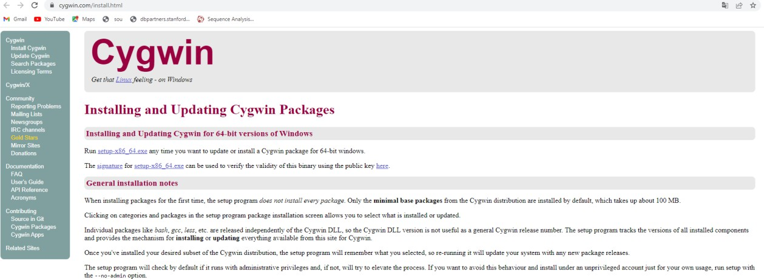

1. **Run the installer (setup) Click next**

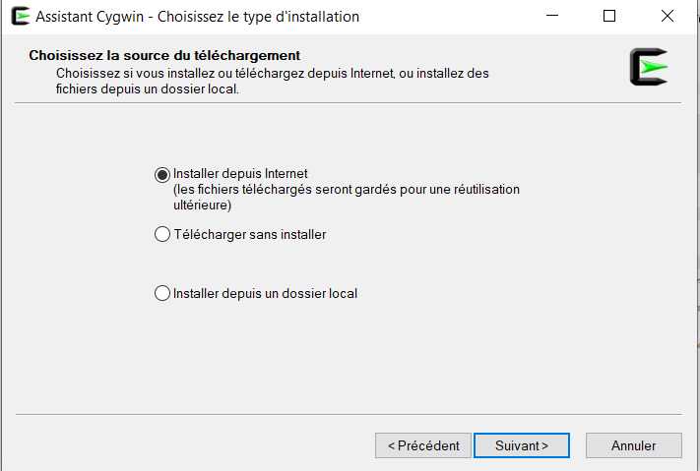

1. **Click Next**

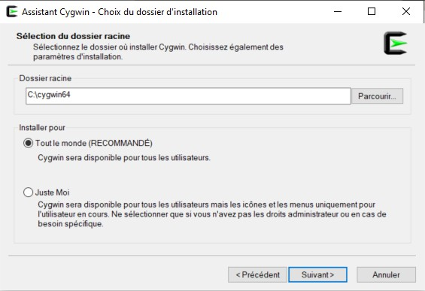

1. **Choose a path where you would want the Cygwin packages to be installed. Click on browse and select your folder. Click next after selecting a folder**

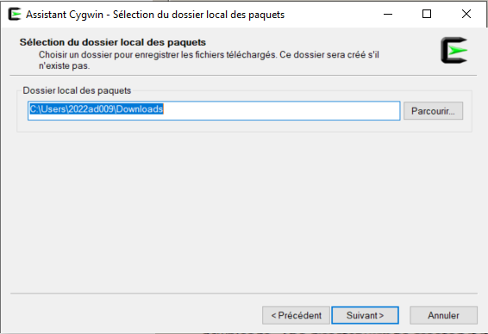

1. **Click next**

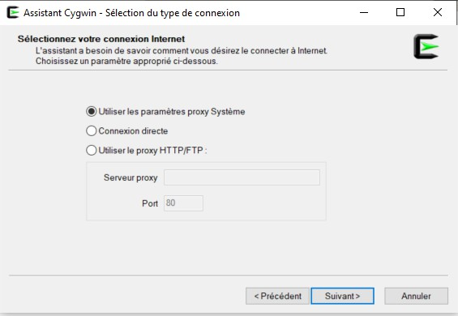

1. **Select a mirror (any) and Click next (It will take a few seconds)**

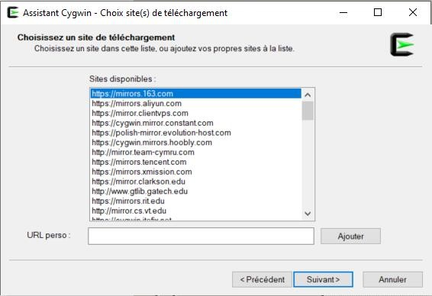

1. **Install additional packages “nano” and “wget”. To do that, go to Category and select Not installed. Then type “nano” and then “wget” in the search box. Click on the drop-down menu to select the last version of nano and wget, then click on next**

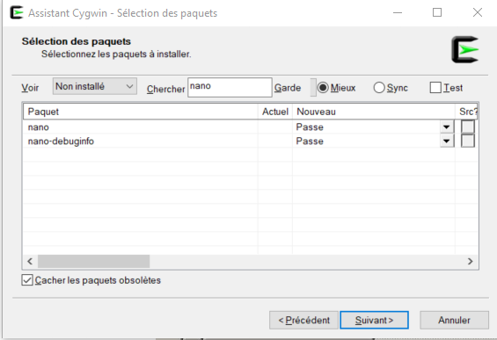

**Drop-down menu**

1. **You will see the download/install progress. If no errors occur, you will be prompted to create a desktop icon and finish the installation**

